
Islamic Relief Worldwide-Bangladesh
Humanitarian Assistance and Early Recovery Department

Community Based Safe water Supply and Hygiene Promotion Project. GUS-Bangladesh
Funded by: Islamic Relief-Germany
Local Partner: Garib Unnayan Sangstha (GUS)
PROJECT PROFILE
Ref: BGL/GRM/STW/34/2011-12

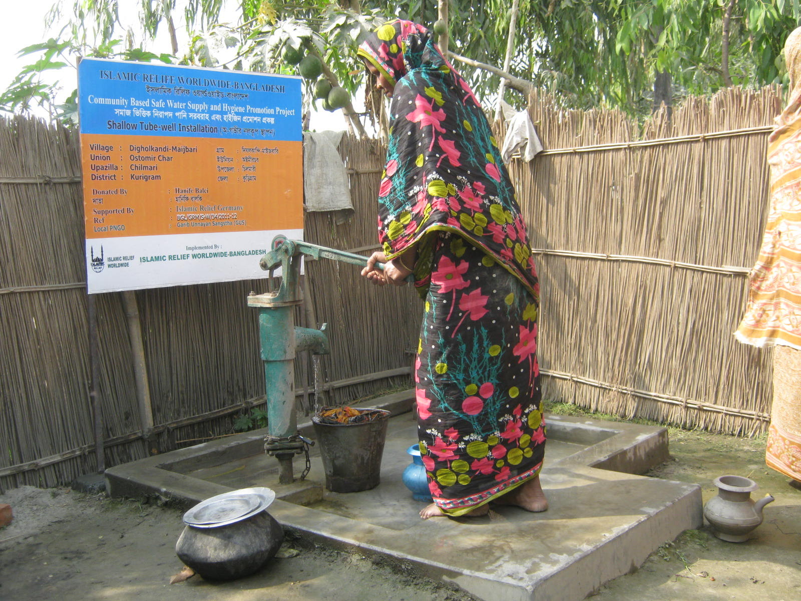

Project Location& Caretaker | : |  | Name : Md. Meher Ali  Village: DiGholkandi Maijbari  Union-Ostomir Char, Upazila: Chilmari  District: Kurigram, Country: Bangladesh
Type of Project | : |  | Wat-San
Depth of Tube-well | : |  | 90’-0”
Potential Beneficiaries | : |  | Direct-10 families & Indirect: 50 Persons
Maintenance Team Member | : |  | Two (02) Persons
Date Started | : | 07 September- 2011
Date Finished | : | 20 October- 2011

____________  Md.Abdul Latif  Executive Director  Garib Unnayan Sangstha(GUS) | _________________  Golam Motasim Billah  Program Manager-HAER  Islamic Relief Worldwide | __________  Javed Ameer  HoP & Acting Country Director  Islamic Relief Worldwide

