
Islamic Relief Worldwide-Bangladesh
Humanitarian Assistance and Early Recovery Department

Community Based Safe water Supply and Hygiene Promotion Project. GUS-Bangladesh
Funded by: Islamic Relief-Germany
Local Partner: Garib Unnayan Sangstha (GUS)
PROJECT PROFILE
Ref: BGL/GRM/STW/38/2011-12

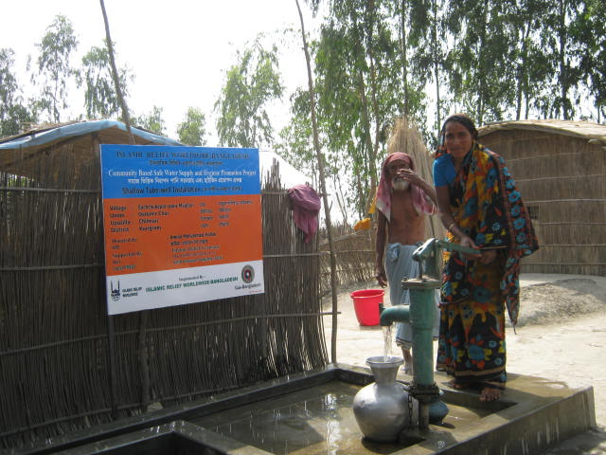

Project Location & Caretaker | : | Name:Mst.Kohinur khatun  Village:BachchuBapari,para Maijbari  Union-Ostomir Char, Upazila: Chilmari  District: Kurigram, Country: Bangladesh
Type of Project | : | Wat-San
Depth of Tube-well | : | 90’-0”
Potential Beneficiaries | : | Direct-10 families & Indirect: 50 Persons
Maintenance Team Member | : | Two (02) Persons
Date Started | : | 07 September- 2011
Date Finished | : | 20 October-2011

-------------------  Md.Abdul Latif  Executive Director  Garib Unnayan Sangstha(GUS) | ----------------------------  Golam Motasim Billah  Program Manager-HAER  Islamic Relief Worldwide | ----------------  Javed Ameer  HoP & Acting Country Director  Islamic Relief Worldwide

